**New New Dis-England, Wiltshire, Ridgeway Area, Neolithic Flint Tools-6,000 BCE-5000 BCE**

**Scrapers, Gravers, Burins**

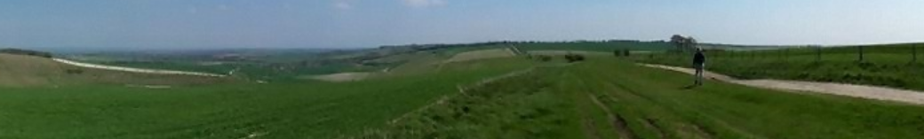

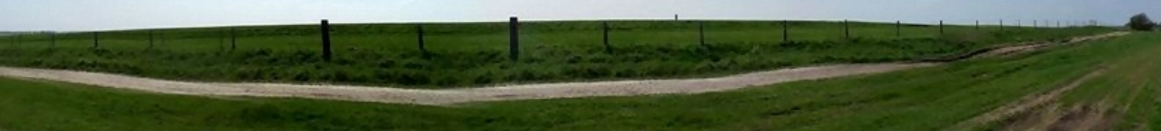

[**https://upload.wikimedia.org/wikipedia/commons/7/7d/Ridgeway_20040424.jpg**](https://upload.wikimedia.org/wikipedia/commons/7/7d/Ridgeway_20040424.jpg)